**MATLAB Homework 01**

Yifu Huang

**Codes location:** <https://github.com/yifuhhh/EE385J_Biomed_Image/tree/master/HW01>

1. Explain the process of acquiring and reconstructing CT images and how we can use MATLAB to simulate that.

CT images is acquired by X-ray measurements from different angles to produce cross-sectional images of specific areas of an object. The reconstruction process is to use the acquired image data to compute the attenuation coefficient of each point on the image, so that the image could be reconstructed.

We can calculate the Fourier transform in the projection in MATLAB, then get the attenuation coefficient, then transverse Fourier transform.

1. Plot a line profile of image_01.

Fig. 1 Line profile of Image_01.

This profile displays a two-dimensional graph of the intensities of pixels along a line within the image. The x-axis represents distance along the line and the y-axis is the pixel intensity. From this plot, we can tell there are peaks around the positions of 250, 600 and 850 mm.

1. Create functions from the scripts we wrote in-class.

See the codes.

1. Calculate line profiles and then reconstruct image_01, using the functions your created.
2. Using 3, 10, 30, 180 evenly spaced back projections. Provide images of both the filtered and unfiltered approach

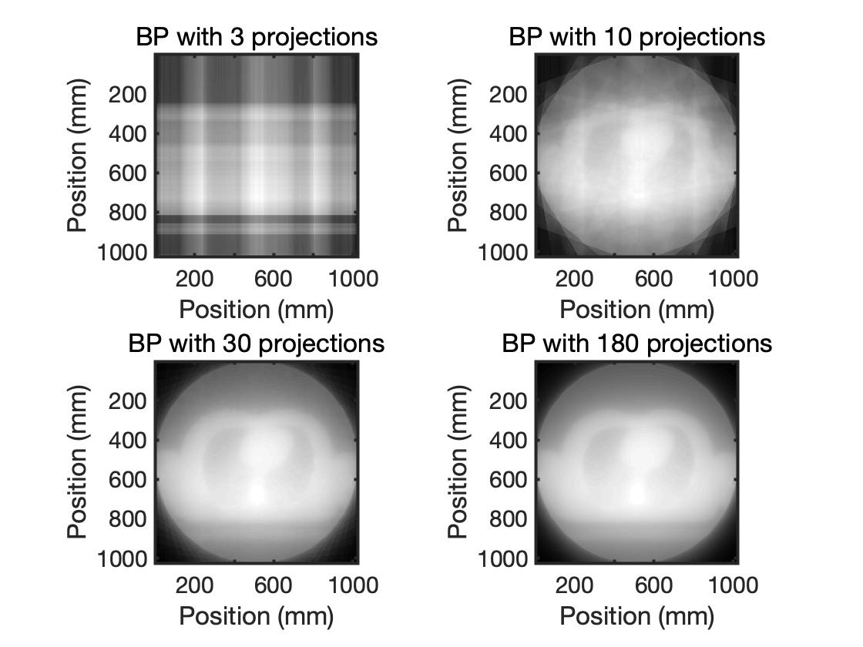

Fig. 2 Unfiltered back projection.

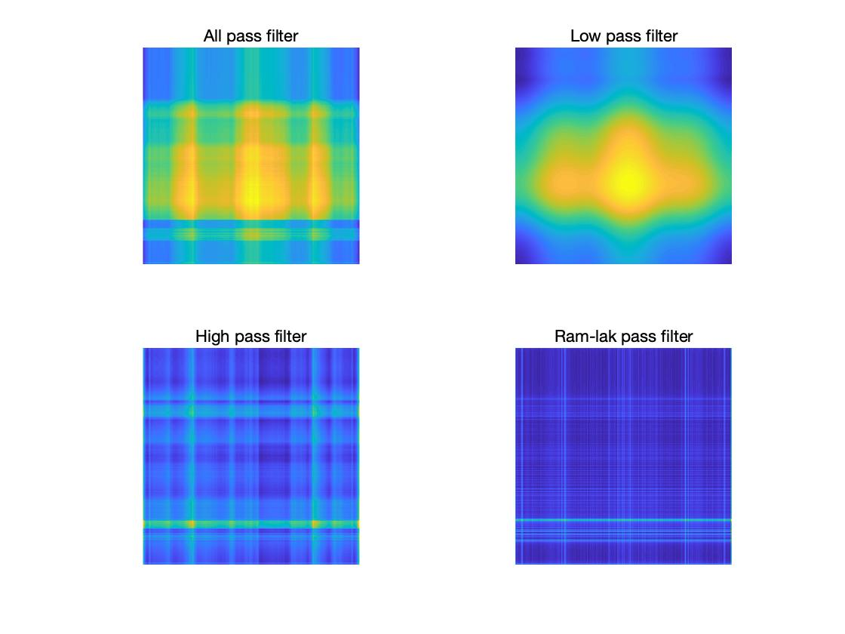

Fig. 3 Filtered back projection, 3 evenly spaced

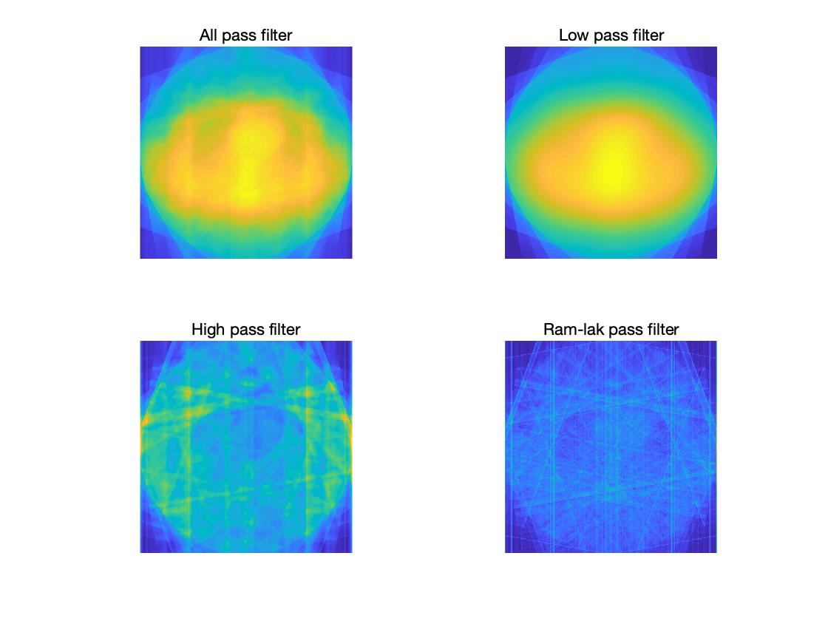

Fig. 4 Filtered back projection, 10 evenly spaced

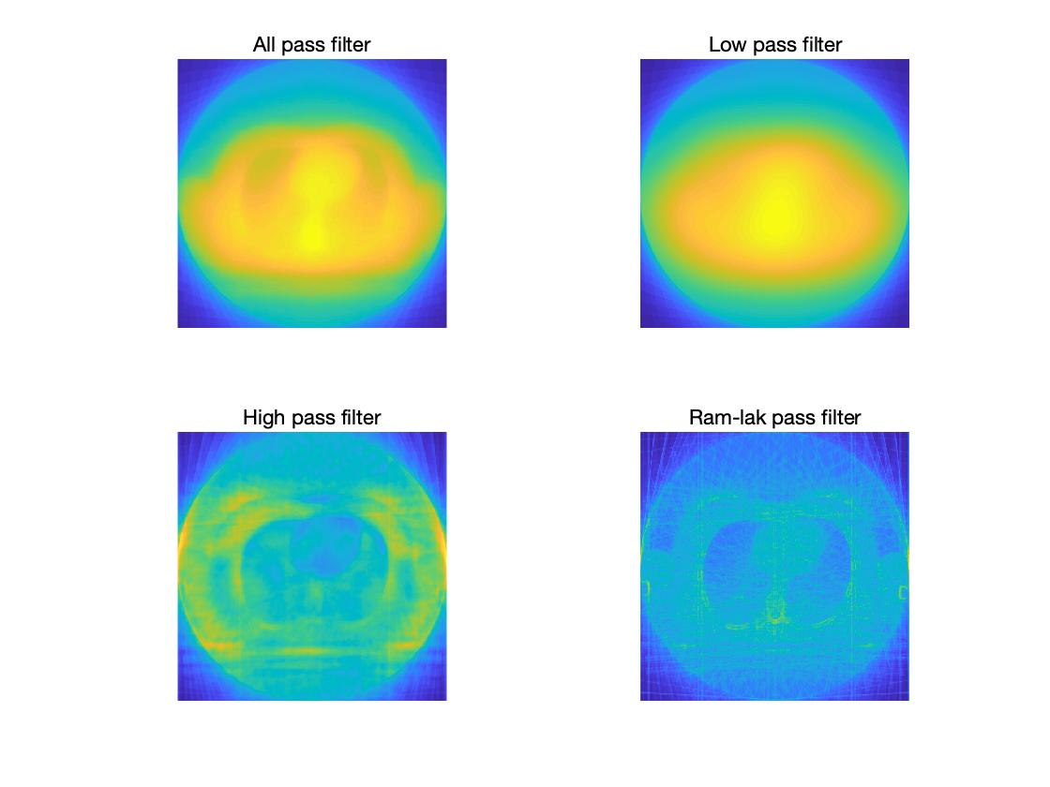

Fig. 5 Filtered back projection, 30 evenly spaced

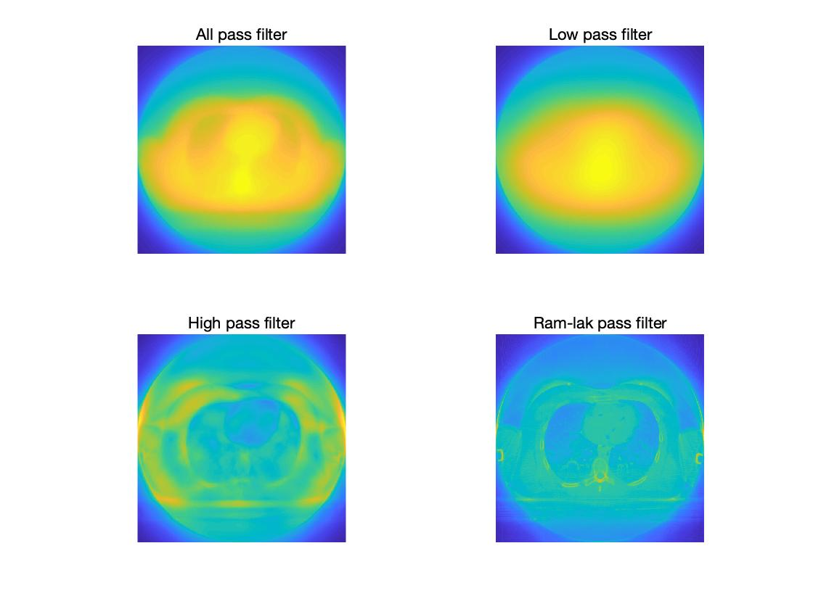

Fig. 6 Filtered back projection, 180 evenly spaced

1. Why is filtering needed?

It helps get rid of the frequency we don’t need when doing reconstruction of images, so that we can easily target the tissues which is damaged or abnormal.

1. Explain how increasing the number of projections improves the image quality. Can you think of any limitations you might have when doing this in humans?

By increasing the number of projections, the image quality would be improved because the information loss in reconstruction would be reduced. The limitation should be the amount of radiation human can tolerate.

1. Calculate line profiles and then reconstruct image_02.
2. Use the iradon and radon functions to reconstruct these images
3. Using 3, 90, 180, 270, 1000 evenly spaced back projections, reconstruct the image

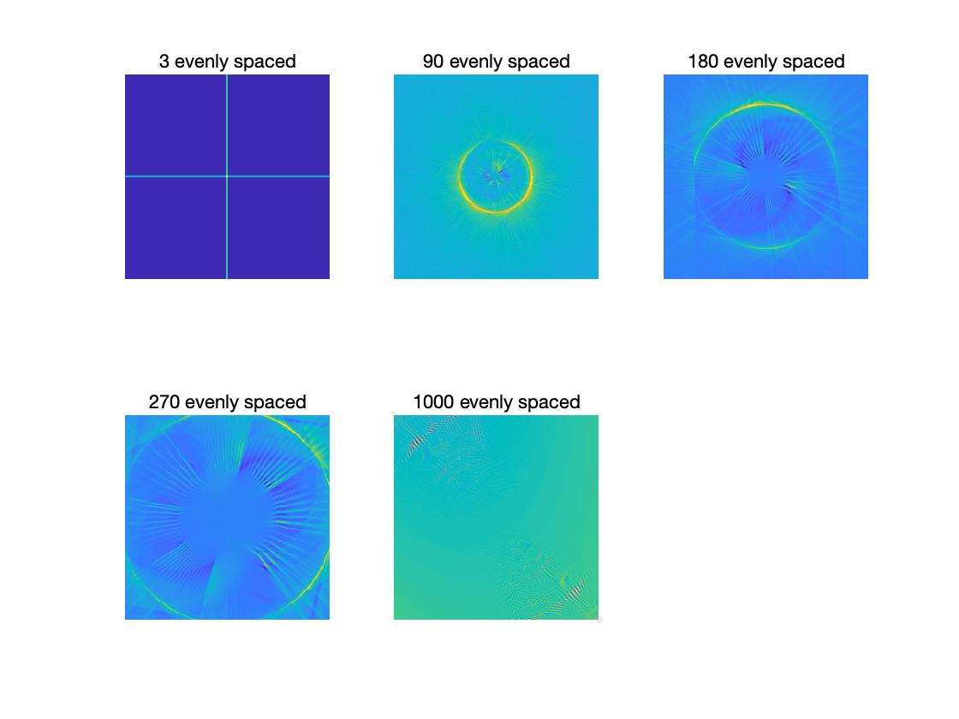

Fig. 7 Reconstruction of image_02 using radon and iradon

1. What can an image like this tell us about the performance of a CT scanner?

The performance of CT scanner is not only defined by the number of projections, but also the attenuation correlation we use in the back projection. Here we set the parameter as “linear”, which is not suitable for the original image.